**DBMS Project – Airplane Crash**

**Module 2**

**Requirements:**

1. Populate your tables with representative sample data. Ensure that at least one main table has a minimum of 25 records. This can be a customer/employer/product/user or similar table that works well with your data. **Any relational DBMS such as Access, MS SQL, SQL Server or Oracle DB can be used as the platform for creating your database.**
2. Create minimum of 3 SQL Queries or Statements to include with your submission that would demonstrate how your database functions. Your SQL statements should include a query to retrieve data, an insert statement to modify existing data, and a delete or update statement to append or remove data from at least one table.
3. Normalize your data as needed to at least Third Normal Form or BCNF.

**Implementation:**

* **Create Table Queries**
  + **PASSENGER Table**

* + **COMPANION Table**

* + **TICKET Table**

* + **SEAT Table**

* **According to the requirement, I have populated the 30 records in each table.**
* **PASSENGER Table**

* **COMPANION Table**

* **TICKET Table**

* **SEAT Table**

* **SQL Queries:** We can perform following SQL queries according to the requirements.

**Q1.** How many passengers have been survived from 'Business' Class?

**Q2.** How many passengers have been died from 'Economy' Class?

Q3. Find out the Passenger names, age, FEMALE gender who have died in the business class, in Airplane Crash.

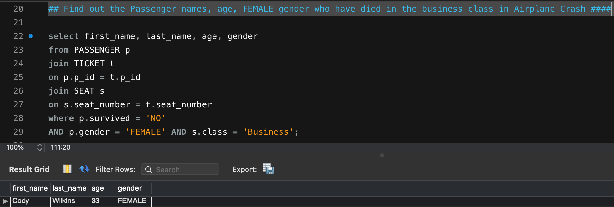

Q4. How many passengers have been survived who were having children with them?

Q5. How many passengers have been died who were having children with them in Business class?

Q6. Insert a new companion_type and special_seat to COMPANION table for particular Passenger.

Q7. Update the companion type in Companion table for particular passenger in the airplane crash.

Q8. Make the changes for one PASSENGER in Passenger table who has been confirmed as dead,

but the confirmation got wrong and we want to change it to survived. (Update on Passenger – Survival – NO to YES)

Q9. Delete some Passenger records who have survived and age is between 1 to 5.

* + **Normalization:** We have normalized our database in the **BCNF/3NF** as discussed.